Fast**National University of Computer and Emerging Sciences, Karachi Fall’2023, FAST School of Computing**

**Midterm Examination**

**19th October 2023, 1:15pm – 02:45pm**

|  |  |  |
| --- | --- | --- |
| **Course Code: CL2005** | **Course Name: Database Systems Lab** | |
| **Instructor Name(s): Mr. Sohail Ahmed, Muhammad Nadeem Ghouri** | | |
| **Student ID:** | | **Section:** |
| **Total Time: 90 Minutes** | | **Total Points: 50 Points** |

# Instructions:

* Return the question paper mention your **student ID on it.**
* Read each question completely before answering it. **There are 3 questions on 2 pages**.
* Attempt all the given questions. **All questions are carrying different points**.
* **Cheating in any case will lead to F-GRADE as per university rule.**
* In case of any ambiguity, you may make assumption. But your assumption should not contradict any statement in the question paper.

|  |  |
| --- | --- |
| **Question # 1: SQL Queries** | **[10 Points]** |

1. Write a query to display job titles with the lowest average commission percentage and lists them in ascending order by commission percentage.
2. Write a query to display lists of job titles with an average salary above $6000.
3. Write a query to find out the given output.

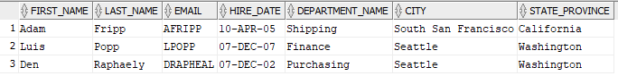

1. Write a query to display the first name and department id of all employees including the first name of their manager.
2. Write a query to display the first name, last name, department name, and salary of the most experienced employee in each department.
3. Write a query to find out the given output.

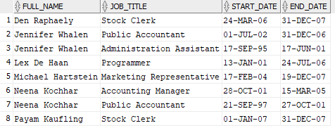

1. Write a query to display the first name, last name, salary and job id of employees with the highest salary in their job title.
2. Write a query to display the employees whose salaries are greater than both the average salary in their department and the average salary for their job title.
3. Write a query to display the first name, last name, email and salary of manager who is supervising more 5 than employees.
4. Write a query to find out the given output.

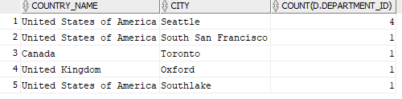

|  |  |
| --- | --- |
| **Question # 2: DDL** | **[20 Points]** |

You are tasked with designing a comprehensive database for a library management system. The database should not only track information about books, authors, and library patrons but also incorporate additional complexity to handle various scenarios effectively. Create the necessary tables and constraints to implement this system. Identify the key constraints and set as per the nature of the Scenario.

**Create a table named "Authors" with the following columns:**

1. author_id
2. first_name
3. last_name
4. birth_date

C**reate a table named "Books" with the following columns:**

1. book_id
2. title
3. publication_date
4. author_id
5. available_copies (Should be >= 0)

**Create a table named "Patrons" with the following columns:**

1. patron_id
2. first_name
3. last_name
4. email (Unique)

**Create a table named "BorrowedBooks" to track book loans with the following columns:**

1. loan_id
2. book_id
3. patron_id
4. loan_date
5. return_date
6. returned (Should be 'Y' or 'N')

After Creating Tables, Perform the following queries:

1. Write an SQL statement to insert a new author into the Authors table with the following information:
2. First Name: Soahil
3. Last Name: Ahmed
4. Birth Date: 2000-01-02
5. Write an SQL statement to insert a new book into the Books table with the following information:
6. Title: "The Catcher in the Rye"
7. Publication Date: 2005-07-16
8. Author: Sohail Ahmed
9. Available Copies: 5
10. Write an SQL statement to insert a new patron into the Patrons table with the following information:
11. First Name: Mohammad
12. Last Name: Nadeem
13. Email: [m.nadeem@example.com](mailto:m.nadeem@example.com)
14. Write an SQL statement to record that Mohammad Nadeem borrowed "The Catcher in the Rye" on 2023-03-10. Set the return date to NULL and indicate that the book has not been returned yet.
15. Write an SQL statement to update the available copies of "The Catcher in the Rye" to 4 after a patron borrowed a copy.
16. Write an SQL statement to mark that Mohammad Nadeem has returned the book he borrowed on 2023-03-15.
17. Update the number of books when books are returned.
18. Retrieve the Author full name, Book title (As Capital), Patron name, book_id, returned status and Loan Date (with Name of the Day) using joins or subqueries.

|  |  |
| --- | --- |
| **Question # 3: Relational Modeling** | **[20 Points]** |

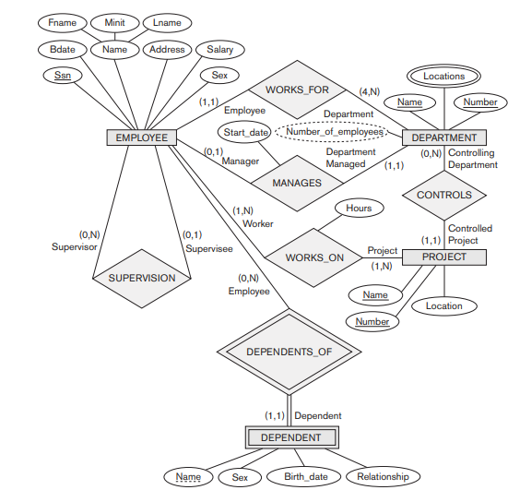

1. Develop the Logical Model.
2. Develop the Relational Model.
3. Generate DDL.

**“If there is something, you don’t know today. You will surely learn afterwards. Life is not an exam, hall.”**

**BEST OF LUCK☺**